# Install & configure Maven build tool on Jenkins

Maven is a code build tool which used to convert your code to an artifact. this is a widely used plugin to build in continuous integration

#### Prerequisites

1. Jenkins server

#### Install Maven on Jenkins

1. Download maven packages <https://maven.apache.org/download.cgi> onto Jenkins server. In this case, I am using /opt/maven as my installation directory

* Link : <https://maven.apache.org/download.cgi>
* # Creating maven directory under /opt
* mkdir /opt/maven
* cd /opt/maven
* # downloading maven version 3.6.0
* wget http://mirrors.estointernet.in/apache/maven/maven-3/3.6.1/binaries/apache-maven-3.6.1-bin.tar.gz

tar -xvzf apache-maven-3.6.1-bin.tar.gz

rename to mv apache-maven-3.6.1 maven

1. Setup M2_HOME and M2 paths in .bash_profile of the user and add these to the path variable
2. vi ~/.bash_profile
3. M2_HOME=/opt/maven/apache-maven-3.6.1
4. M2=$M2_HOME/bin

PAHT=<Existing_PATH>:$M2_HOME:$M2

#### Checkpoint

1. logoff and login to check maven version

mvn --version

So far we have completed the installation of maven software to support maven plugin on the jenkins console. Let's jump onto Jenkins to complete the remaining steps.

### Setup maven on Jenkins console

1. Install maven plugin without restart

* Manage Jenkins > Jenkins Plugins > available > Maven Invoker
* Manage Jenkins > Jenkins Plugins > available > Maven Integration

1. Configure maven path

* Manage Jenkins > Global Tool Configuration > Maven

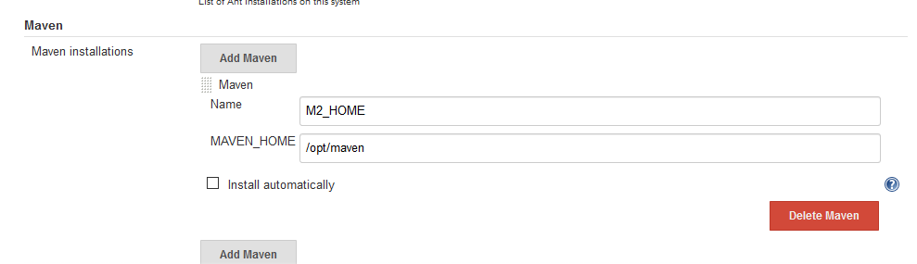

Running Maven Build Job

